Domayne’s Delmard Sofa

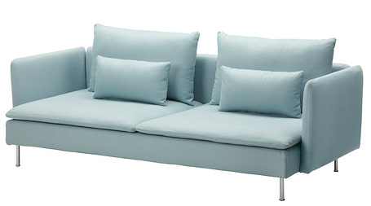

|  |
| --- |
| **DESCRIPTION** |
| The contemporary Delmard, produced by Domayne’s Sofa, presents a sleek, low profile design that is both functional and comfortable. The extra-wide and deep relaxed form on top and extra long legs on bottom provides stability for the sofa. Available in Grey, white or red bonded air tight with bulky form and hand stitched leather, the Delmard air filled leather with thick form will add comfort and class to drawing room. |

|  |  |  |
| --- | --- | --- |
| **Price** | **1200$** | |
| **Dimensions** | **H** x **W** x **L** | **28in x 32in x 66in** |
| **Features** | **Comfortable for two but 4 people can also sit at once with air tight pressure and shock absorbers enable it to have long healthy life.** | |
| **Finished** | **Grey Condensed Form** | |
| **Available in** | **Grey, Brown and Red** | |